hdfs dfs

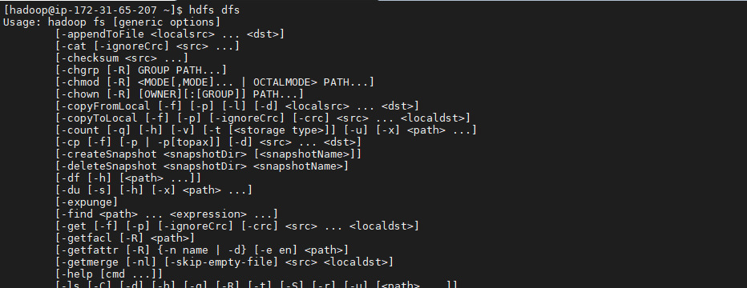

hdfs dfs -ls /

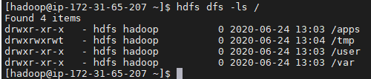

hdfs dfs -mkdir test

hdfs dfs –ls

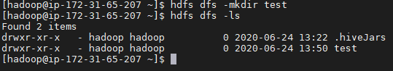

hdfs dfs -mkdir test/test1

hdfs dfs -mkdir -p test/test2/test3

hdfs dfs –ls

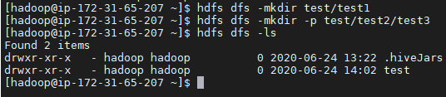

hdfs dfs -ls –R

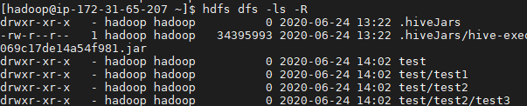

hdfs dfs -rm -R test/test2

hdfs dfs -ls –R

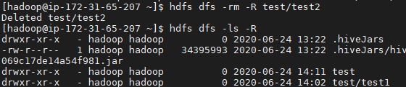

cd /root/labs/Lab2.1/

tail data.txt

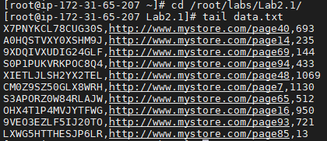

hdfs dfs -put data.txt test/

hdfs dfs -ls test

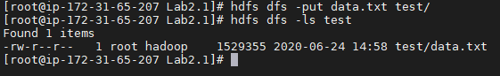

hdfs dfs -cat test/data.txt

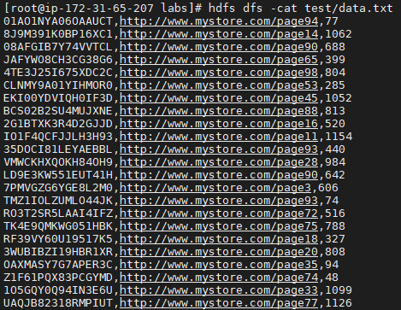

hdfs dfs -tail test/data.txt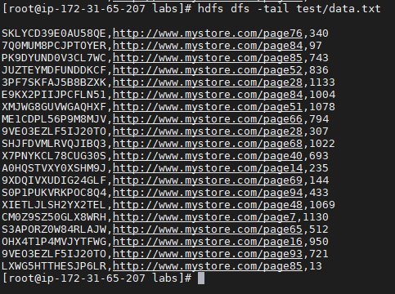

hdfs dfs -get test/data.txt /tmp/

cd /tmp

ls data\*



hdfs fsck /user/root/data.txt

